Appendix C: EXMARALDA and stylesheets

What is a Stylesheet?
A style sheet is an XML-document that contains instructions that can be "understood" and implemented by software (a stylesheet processor) designed to implement it. Normally a stylesheet is used to create a new XML- or HTML-document from a given XML-document. Due to the fact that EXMARaLDA-data is always XML-data, the style sheet technology is most suitable in data processing to establish a high flexibility with a relatively low amount of programming involved. It is not necessary to fully understand this technology in order to make use of stylesheets in the Partitur-Editor effectively. Therefore, no detailed explanation is delivered in this manual. Should you be interested to take a deeper look at this technology, we recommend the following as an introductory work:

Michael Fitzgerald (2003): Learning XSLT. O’Reilly.

The use of Stylesheets
Within EXMARaLDA the purpose of the stylesheet is to take on reoccurring transcription tasks that are regular enough to be automated, yet the exact procedure relies on parameters that differ from user to user. Due to the fact that it is not possible to predict and integrate all potential parameters for these tasks into the Partitur-Editor, the Editor possessed a number of functions that allow for user defined parameters to be set for stylesheets.

Examples of these tasks are:

- When creating a tier, a specific number of tiers should be added for every speaker automatically. The parameters for this task can depend on the transcription conventions used, for example. E.g., if a transcription is made according to the HIAT-conventions, every speaker needs a verbal tier, a tier for special pronunciation and a tier for comments. For a DIDA-transcription, only a verbal tier and a comment tier are required per speaker, as well as a golbal comment tier. By using a suitable stylesheet in combination with the function “File > New from speakertable”, this task can be automated:

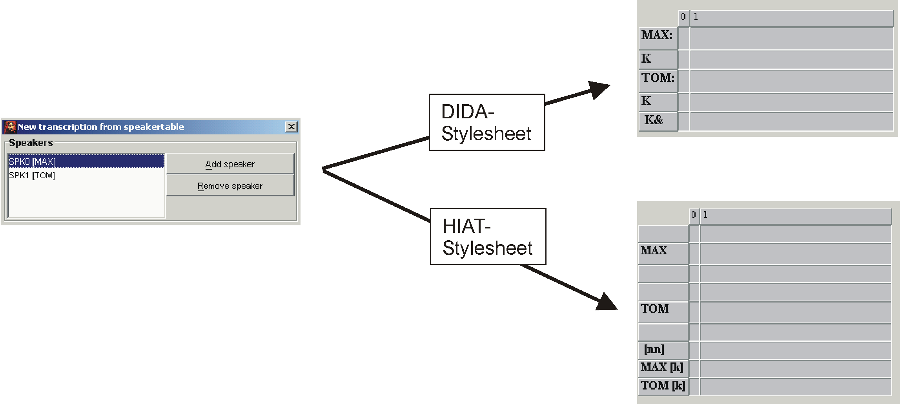

2. An existing transcription is to be formatted automatically subject to the tier types e.g. all tiers of category "v" should be formatted in "Arial, 12pt, bold“ and all tiers of category "nv“ should be formatted in "Times, 10pt, italic“.

3. A HIAT-utterance list should be issued as an HTML-file, the individual utterances should be numbered and all annotation and description should be hidden.

Where to get Stylesheets?
There are three ways to get stylesheets for the use in the Partitur-Editor:

- Download of a ready to use stylesheet from the EXMARaLDA website:
The EXMARaLDA website offers a number of ready to use stylesheets to download. The majority of these stylesheets is designed for transcriptions with the transcription systems HIAT and DIDA.

2. Adapting an already existing stylesheet:
The actual purpose of a stylesheet – i.e. the user-dependent setting of parameters as an automated task – can only be fulfilled if the user creates the stylesheet in question himself. For many users creating a stylesheet "from scratch" would be of too much effort. It often suffices to adjust a simple already existing stylesheet to the needs of the user (e.g. one of those found on the EXMARaLDA website). The following example illustrates why this option can be easier than learning the entire stylesheet language: The section to the left is a part of a stylesheet from the EXMARaLDA website. It assists in generating a format table. It defines that a tier of category "v“ should be formatted in "Arial, normal, 16pt, black“. A modification of the stylesheet (see the section to the right) can leave the majority of the instructions unaltered and only change the sections highlighted in yellow:

<!-- Format for verbal tiers-->  <xsl:when test="@category='v'">  <xsl:element name="tier-format">  <xsl:attribute name="tierref">  <xsl:value-of select="@id"/>  </xsl:attribute>  <property name="font-name">Arial</property>  <property name="font-face">Plain</property>  <property name="font-size">16</property>  <property name="font-color">black</property>  […]  </xsl:element>  </xsl:when> | <!-- Format for verbal tiers-->  <xsl:when test="@category='v'">  <xsl:element name="tier-format">  <xsl:attribute name="tierref">  <xsl:value-of select="@id"/>  </xsl:attribute>  <property name="font-name">Times</property>  <property name="font-face">Italic</property>  <property name="font-size">12</property>  <property name="font-color">blue</property>  […]  </xsl:element>  </xsl:when>
Arial | Times

3. Creating own stylesheets:
Creating own stylesheets is both the most complex and the most extensive method. A knowledge of the code of the Partitur-Editor is not required, it suffices to be familiar with the structures of EXMARaLDA-XML-files.

Using Stylesheets in the Partitur-Editor
To be able to use stylesheets in the Partitur-Editor, the stylesheets that you would like to make use of need to be defined under: Edit > Preferences > Stylesheets. Thereafter the functions in question can be called. There are five functions in the Partitur-Editor that allow their parameter to be set with stylesheets:

- File > New from speakertable
This is the above illustrated option. It allows tiers in a new transcription to be generated automatically from the speakertable.

- File > Visualize > HTML partitur
Here, a stylesheet can be used to issue meta information and speakertables (the so-called transcription head) in a user-defined way. For example, different stylesheets can be used to issue the attribute name in different languages:
Without stylesheet:

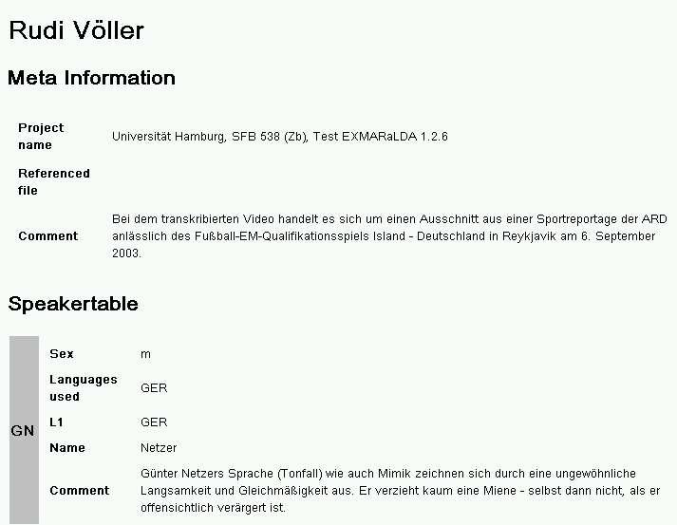

With “Head2HTML_de.xsl“:

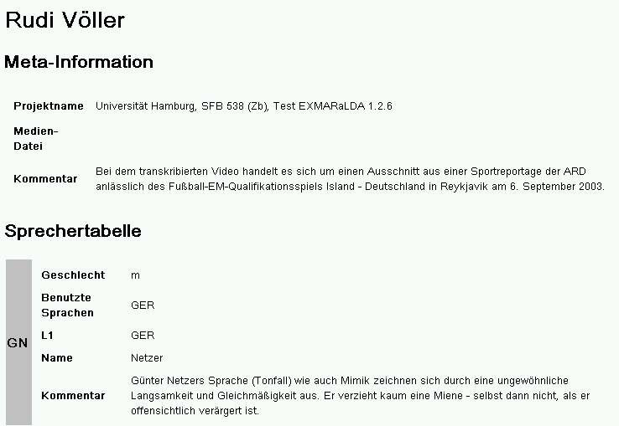

- File > Visualize > Free stylesheet visualization
Here the stylesheet is applied to the entire basic transcription. In this manner, representations of the transcription in musical score or column notation or as a list of events for example are generated:

With “BT2ColumnHTML.xsl“:

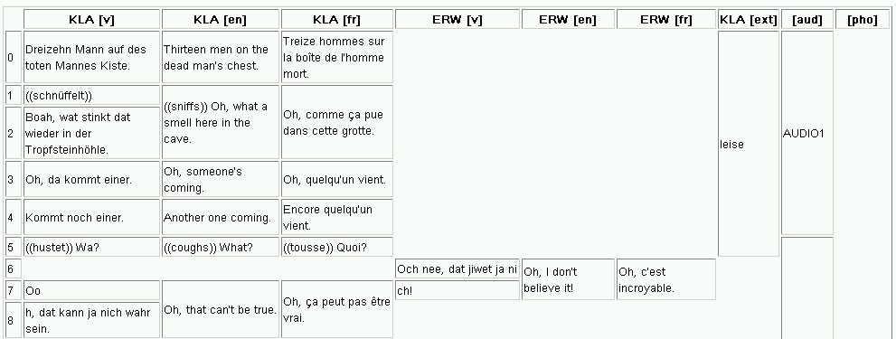

With “BT2PartiturHTML.xsl“:

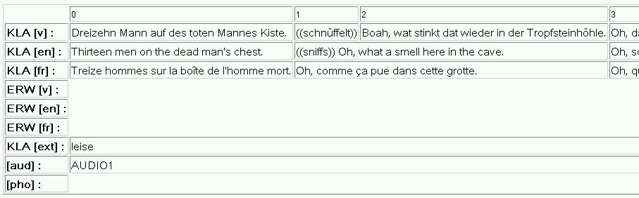

With “BT2EventListHTML.xsl“:

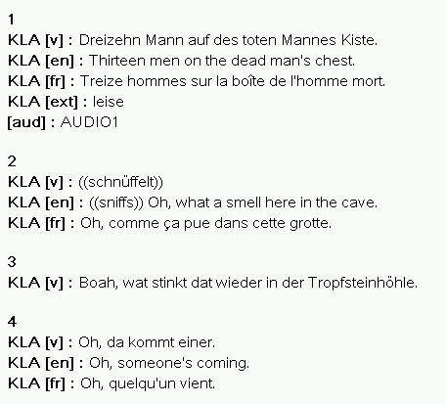

- Format > Apply Stylesheet
Here a format table is created from the transcription with the help of a stylesheet and used in the Editor afterward.

- Segmentation > HIAT segmentation > Utterance list (HTML)
Here a stylesheet is applied to an utterance list – this is a list transcription that is segmented into utterances in accordance to HIAT:

Without stylesheet:

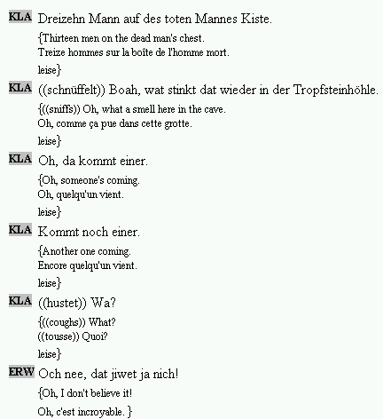

With “HIAT_PlainUtteranceList_Tbl.xsl“:

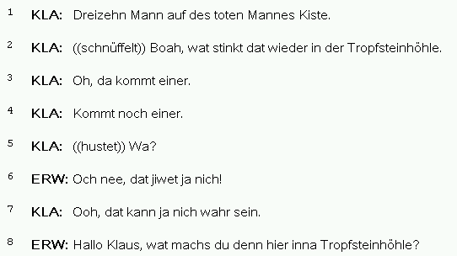

With “HIAT_PlainUtteranceList_Txt.xsl“:

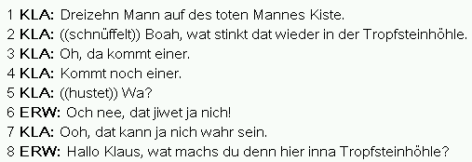

With “HIAT_ColoredUtteranceList.xsl“:

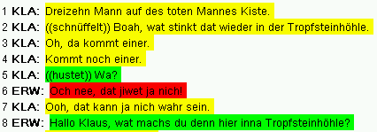

Appendix D: Shortcut Overview

Note to Macintosh users: For most shortcuts, ctrl corresponds to ⌘.
Note to german users: On the German keyboard strg is equivalent to ctrl .

1. Audio / Video Player
ctrl + space | Play selection
ctrl + shift + space | Play last second of selection
ctrl + F4 | Play
ctrl + F5 | Pause
ctrl + F6 | Stop
2. Waveform display / selection
mouse wheel | move left selection boundary (when near left boundary)  move right selection boundary (when near right boundary)  move selection (when near selection centre)
alt + shift + ← | Decrease selection start
alt + shift + → | Increase selection start
alt + ← | Decrease selection end
alt + → | Increase selection end
ctrl + shift + s | Shift selection
ctrl + mouse wheel | Zoom waveform in/out
ctrl + shift + mouse wheel | Vertical zoom for waveform
3. File menu
ctrl + n | New transcription...
ctrl + o | Open transcription...
ctrl + s | Save transcription...
ctrl + p | Print transcription...
4. Edit menu
ctrl + z | Undo
ctrl + c | Copy
ctrl + v | Paste
ctrl + x | Cut
ctrl + f | Search in events...
ctrl + w | Find next
ctrl + h | Replace in events...
ctrl + g | Go to...
ctrl + shift + f | EXAKT search...
5. Tier menu
ctrl + a | Add tier...
ctrl + i | Insert tier...
ctrl + ↑ | Move tier upwards
ctrl + alt + h | Hide tier
6. Event menu
ctrl + enter | Event properties...
ctrl + d | Remove event
ctrl + shift + r | Shift characters to the right
ctrl + shift + l | Shift characters to the left
ctrl + 1 | Merge events
ctrl + 2 | Split event
ctrl + 3 | Double split event
ctrl + shift +  | Extend event to the right
ctrl + shift +  | Extend event to the left
ctrl + alt +  | Shrink event on the right
ctrl + alt +  | Shrink event on the left
ctrl +  | Move event to the right
ctrl +  | Move event to the left
ctrl + alt + n | Find next event
7. Format menu
ctrl + u | Underline

Appendix E: SYNCHRONISATION OF AN EXMARALDA TRANSCRIPTION WITH A DIGITALISED AUDIO RECORDING IN PRAAT

Preparation

1. Copy the audio file to the hard drive (has to be either .aiff- or .wav-Format).

2. Start EXMARaLDA Partitur-Editor (Version 1.3 or higher)
  - If the PRAAT panel is not displayed, select: View > Show panels > Praat panel
  - Open the transcription to be edited
  - Arrange main window (musical score) and Praat panel so that they do not overlap and that there is some space left for PRAAT, e.g.:

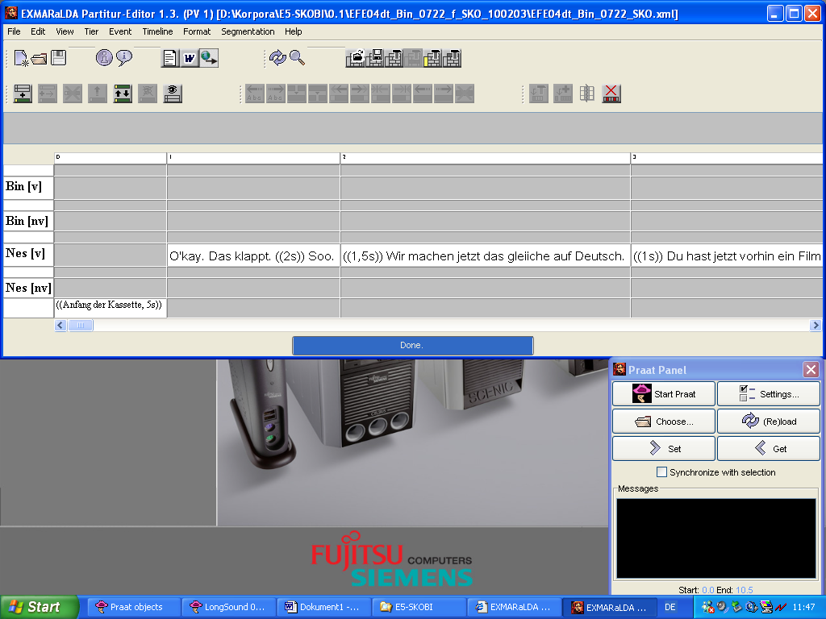

3. Edit meta information (File > Meta-Information…)
- Click Browse… next to „Referenced File“, look for the audio file on your hard drive and close the dialog with OK.

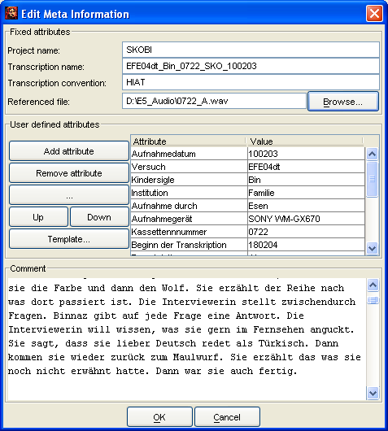

4. Start Praat and set it up
- Click Start Praat in the Praat panel.
- Wait for Praat to start (i.e. until Praat'sWelcome dialog

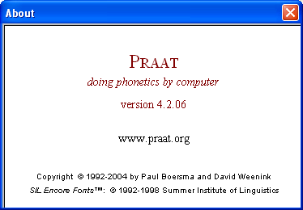

disappears).

- Click OK on the „Starting Praat…“ dialog:

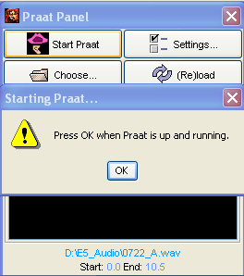

- Close the Praat Picture Window:

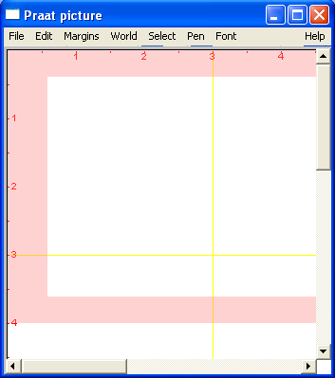

5. Open the audio file in Praat
- Click Reload in the Praat panel.
- Wait until an Editor for „Long Sound [file name]“ is opened in Praat:

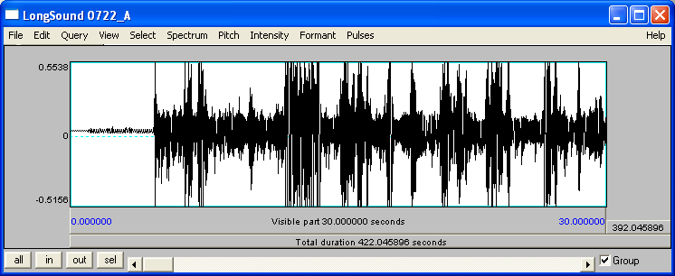

The Editor also appears in the Praat Object Window:

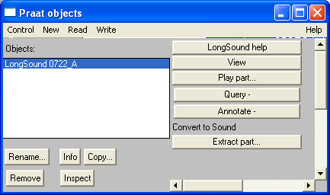

- Organize the Praat Editor Window and Partitur-Editor so that you can see both on the screen:

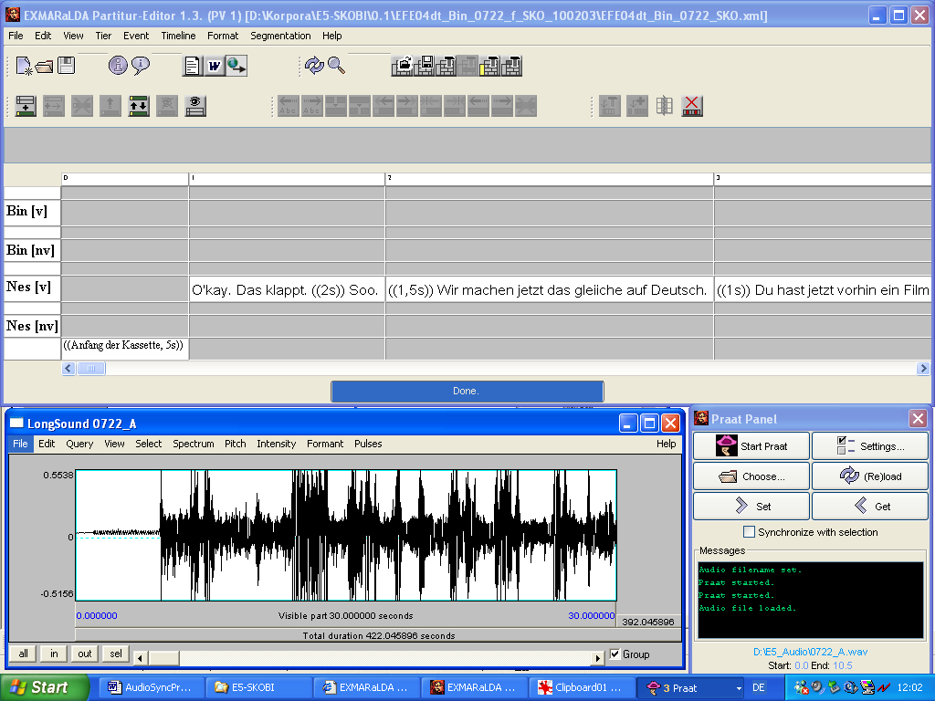

- In the Praat Editor, chose View > Zoom… and enter 0.0 as the beginning and 60.0 as the end value (the oscillogram cannot show more than 60 seconds):

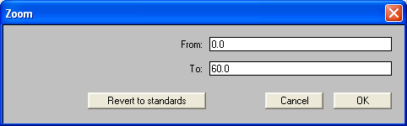

Synchronization
In the Praat-Editor Tab can be used to start and stop playback. The current position is highlighted with a red dotted line. The scroll bar at the bottom of the window allows moving the section you want to view:

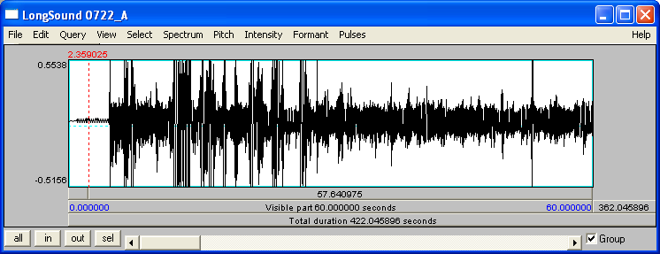

The synchronization of the audio file and the transcription is completed in 3 steps:

- Select a time point in the Partitur-Editor (to do this, click onto the corresponding position on the time axis):

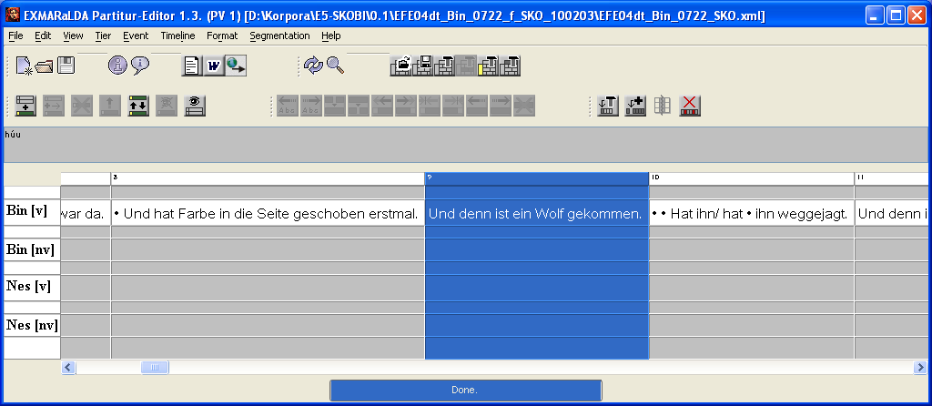

2. Look for the corresponding position in the recording in the Praat-Editor, i.e. move the recording to where the selected element starts.

3. Click Get in the Praat panel. The position of the recording in Praat is assigned to the selected time point in EXMARaLDA as an absolute time value. In the Editor this can be seen by an absolute time value appearing on the time axis:

